**Domain specific Kernels**

It is best to use RBF if don’t have any kernel because it is general purpose kernel but there is also domain specific kernels are available which is developed by domain expertise.

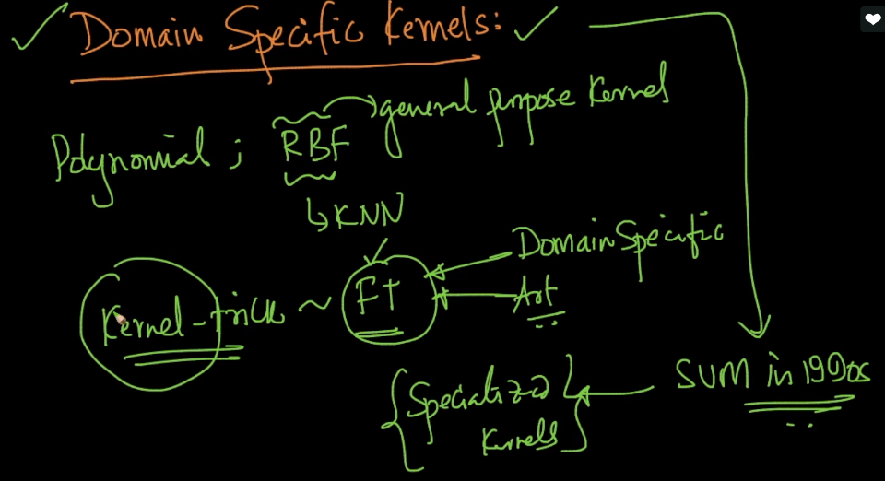

If our data is string then we can use string kernel just we have to search for kernels regarding particular problems

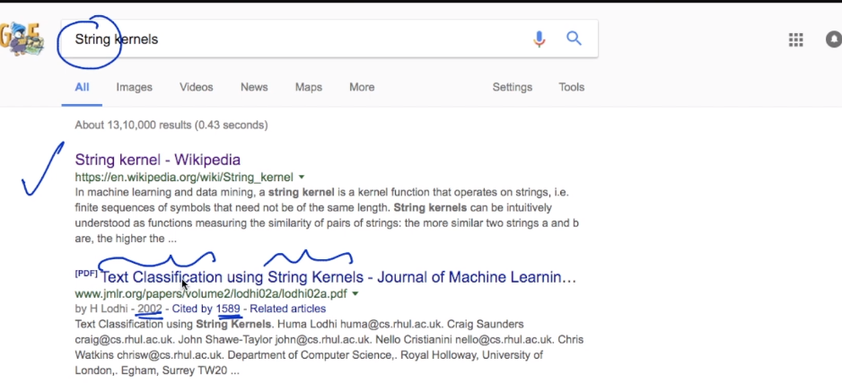

For genes there is genome kernel

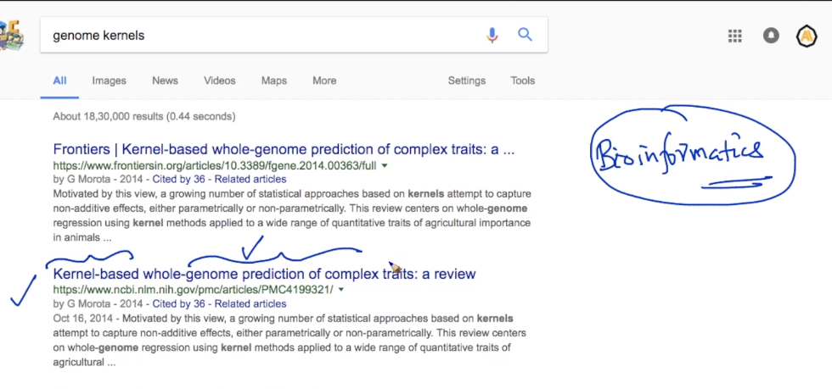

If our dataset is like graph then graph kernels are available

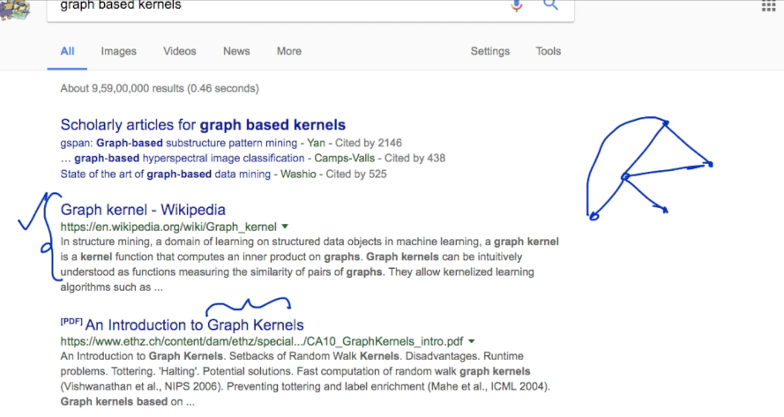

Feature transformation is hard part of ml and we partially replace it by finding right kernel



Comments:

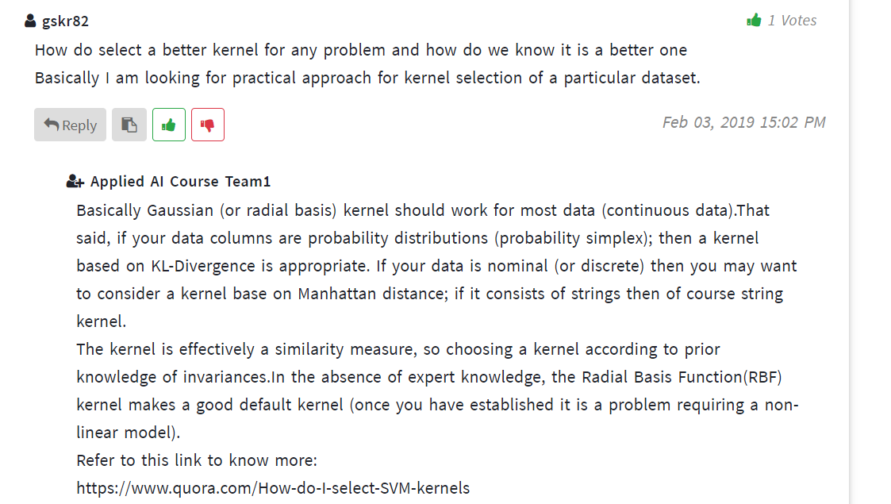

Link:

<https://www.quora.com/How-do-I-select-SVM-kernels>